**Dynamic Testing: Black Box testing: boundary value analysis**

[BVA](https://www.geeksforgeeks.org/boundary-value-analysis-triangle-problem/) is used to check the behavior of application using test data that exist at boundary values or in more easy words, for a range of input data values, boundary values (extreme end values) are used as input for testing. It is mostly used design technique as it is believed that software is most likely to fail at upper and lower limits of input data values.

**Example:**A software allows people of age 20 to 50 years (both 20 and 50 are inclusive) to fill a form, for which the user has to enter his age in the age field option of the software.

The boundary values are 20 (min value) and 50 (max value).

| **Invalid Value**  **(min-1)** | **Valid Value**  **(min, min+1, nominal value, max-1, max)** | **Invalid Value**  **(max+1)** |
| --- | --- | --- |
| 19 | 20, 21, 30, 49, 50 | 51 |

In the above table, one can clearly identify all valid and invalid test values (values consider during testing the system).

1. **Valid value:** Test values at which the system does not fail and function properly as per user requirement.
2. **Invalid Values:** test values that do not meet the system requirement.

**Importance of BVA:**

1. **Efficiency**: Reduces the number of test cases while covering critical points.
2. **Accuracy**: Identifies edge cases that are likely to cause system failures.
3. **Validity**: Ensures the system responds correctly to both valid and invalid data.

QN 02::::::::::::::::::::::::::::::::::::::::::::::::::::::::::::::::::::::::::::::::::::::::::::::::::::::::::::::

**Equivalence Partitioning** (also called **Equivalence Class Partitioning**, ECP) is a black-box testing method used to divide input data into groups or partitions, ensuring that one test case from each partition is enough to represent the behavior of the system for that range.

**Key Concepts:**

1. **Equivalence Classes**: The input domain is divided into valid and invalid equivalence classes. Test cases are then selected from each class to cover the entire domain.
   * **Valid class**: Represents inputs that meet system requirements.
   * **Invalid class**: Represents inputs that do not meet requirements.

**Guidelines:**

* If an input is a range (e.g., 50 to 90%), there is one valid class (values within the range) and two invalid classes (values below and above the range).
* If an input is a specific value (e.g., a Boolean), there are two classes—one valid and one invalid.

**Example 1: College Admission**

In a system where only percentages between 50% and 90% are valid for admission:

* **Valid class**: 50% to 90%.
* **Invalid classes**: Less than 50%, greater than 90%.

**Example 2: Online Shopping Product Search**

In a shopping site, product IDs are used to search for products (e.g., mobiles, laptops):

* **Valid class**: Entering valid product IDs (e.g., 45 for mobiles).
* **Invalid class**: Entering invalid IDs (e.g., a random number not assigned to any product).

| **Product** | **Product ID** |
| --- | --- |
| Mobiles | 45 |
| Laptops | 54 |
| Pen Drives | 67 |
| Keyboard | 76 |
| Headphones | 34 |
|  |  |

**Benefits of Equivalence Partitioning:**

1. **Efficiency**: Reduces the number of test cases needed to cover the input space.
2. **Comprehensive Testing**: Ensures both valid and invalid inputs are tested.

QN 03:::::::::::::::::::::::::::::::::::::::::::::::::::::::::::::::::::::::::::::::::::::::::::::::::::::::::::::::::::::::::::

**State Transition Testing (STT)** is a black-box testing method used to test changes in system states based on different inputs. It evaluates the application's behavior under varying input sequences and helps ensure that transitions between different states occur correctly.

**Objectives of STT:**

1. **Identifying States**: Record all possible states the system can be in.
2. **State Transition Modelling**: Develop a model/diagram showing transitions.
3. **Verifying Transitions**: Check the correctness of state changes based on input.
4. **Start and End States**: Ensure correct system initialization and termination.
5. **Error Handling**: Test how the system handles unexpected inputs or errors.

**State Transition Components:**

1. **States**: Various conditions the system can be in.
2. **Transitions**: Movement from one state to another.
3. **Events**: Inputs that trigger transitions.
4. **Actions**: Tasks performed during transitions.

**Example:**

For a **digital clock**, inputs like “Change Mode” or “Reset” switch between states such as "Time Display," "Date Display," and "Time Set."

**Advantages:**

1. **Clear Visualization**: The state diagram helps in understanding transitions.
2. **Effective Test Design**: Test cases can cover all state changes, including edge cases.
3. **Early Error Detection**: Issues in transitions can be caught early in the development cycle.

**Disadvantages:**

1. **State Identification Difficulty**: Identifying all system states can be complex.
2. **Limited Combinations Testing**: Focuses on individual transitions, not state combinations.
3. **Omission Risk**: Some transitions may be missed, leading to incomplete coverage.

Q4:::::::::::::::::::::::::::::::::::::::::::::::::::::::::::::::::::::::::::::::::::::::::::::::::::::::

**Cause-Effect Graphing** is a black-box testing technique used to identify combinations of input conditions (causes) and their corresponding outputs (effects) using a graphical approach. This method supplements other techniques like boundary value analysis and equivalence partitioning by considering critical combinations of input conditions.

**Steps in Cause-Effect Graphing:**

1. **Division of Specification**: Large specifications are divided into manageable sections for separate analysis.
2. **Identify Causes and Effects**: Causes represent input conditions, and effects denote outputs.
3. **Transform to Graph**: Causes and effects are connected using Boolean logic to form the graph.
4. **Convert to Decision Table**: The cause-effect graph is transformed into a decision table showing input-output relationships.
5. **Derive Test Cases**: Each column of the decision table becomes a unique test case.

**Advantages:**

* **Comprehensive Testing**: It covers complex input combinations.
* **Improves Coverage**: Ensures that all possible cause-effect relationships are tested.

**Basic Notations used in Cause-effect graph:**  
Here **c** represents **cause** and **e** represents **effect**.

The following notations are always **used between a cause and an effect**:

1. **Identity Function:** if c is 1, then e is 1. Else e is 0.

1. **NOT Function:** if c is 1, then e is 0. Else e is 1.

1. **OR Function:** if c1 or c2 or c3 is 1, then e is 1. Else e is 0.

1. **AND Function:** if both c1 and c2 and c3 is 1, then e is 1. Else e is 0.

The following **constraints** are used in cause-effect graphs:

1. **Exclusive constraint** or **E-constraint:** This constraint exists between causes. It states that either c1 or c2 can be 1, i.e., c1 and c2 cannot be 1 simultaneously.

1. **Inclusive constraint**or **I-constraint:** This constraint exists between causes. It states that atleast one of c1, c2 and c3 must always be 1, i.e., c1, c2 and c3 cannot be 0 simultaneously.

1. **One and Only One constraint** or **O-constraint:** This constraint exists between causes. It states that one and only one of c1 and c2 must be 1.

1. **Requires constraint**or **R-constraint:** This constraint exists between causes. It states that for c1 to be 1, c2 must be 1. It is impossible for c1 to be 1 and c2 to be 0.

1. **Mask constraint** or **M-constraint:** This constraint exists between effects. It states that if effect e1 is 1, the effect e2 is forced to be 0.

Q5:::::::::::::::::::::::::::::::::::::::::::::::::::::::::::::::::::::::::::::::::::::::::::::::::::::::;

**White box Testing Techniques**

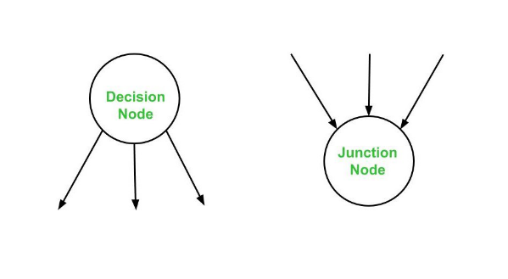

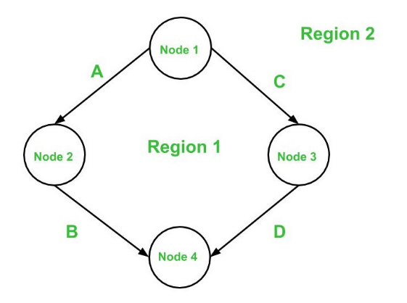

**Basis Path Testing** is a structured white-box testing technique that focuses on the logical control flow of a program. It ensures thorough testing by covering independent paths within the control flow graph of a program, emphasizing maximum logic coverage.

**Steps Involved:**

1. **Control Flow Graph Construction**: A directed graph that represents the flow of control in a program. Nodes represent decisions/statements, and edges represent control flow between them.
2. **Cyclomatic Complexity**: This metric quantifies a program’s logical complexity and helps in determining the number of independent paths. It can be computed using the following formulas:
   * V(G)=E−N+2V(G) = E - N + 2V(G)=E−N+2 (where E = edges, N = nodes)
   * V(G)=P+1V(G) = P + 1V(G)=P+1 (where P = predicate nodes)
3. **Identifying Independent Paths**: An independent path introduces at least one new edge in the control flow graph. Independent paths ensure each edge in the program is executed at least once.
4. **Designing Test Cases**: Test cases are derived for each independent path to ensure complete code coverage.

**Example:**

In a control flow graph, if the cyclomatic complexity is 3, there will be three independent paths. The goal is to design tests for each path to cover all edges.

**Advantages:**

1. **High Coverage**: Provides better code coverage compared to traditional path testing techniques by covering all edges at least once.
2. **Maintenance Testing**: Effective in regression testing by verifying modified sections of code.
3. **Applicable to Unit and Integration Testing**: Suitable for unit testing to ensure that individual modules are thoroughly tested and integration testing for detecting interface errors between modules.
4. **Complexity-Based Testing Effort**: The complexity of the software determines the testing effort, ensuring efficient resource allocation for more complex programs.

Below are the **notations**used while constructing a flow graph :

* **Sequential Statements –**
* **If – Then – Else –**
* **Do – While –**
* **While – Do –**
* **Switch – Case –**

**Q6:::::::::::::::::::::::::::::::::::::::::::::;;;**

**Logic Coverage Criteria** is a fundamental aspect of white-box testing that ensures the thorough testing of a program’s internal logic by examining its control flow and decision-making processes. This method evaluates the logical conditions and decisions in the code to guarantee that all possible outcomes are tested. The goal is to find potential defects by covering different paths in the code. Various levels of logic coverage include:

1. **Statement Coverage**: Tests all executable statements in the program at least once. It helps in identifying dead code and missing functionalities but might not uncover logic flaws in decisions.
   * Example: If a program has 10 statements, statement coverage ensures each one is executed during testing.
   * **Formula**: Statement Coverage=Number of Statements ExecutedTotal Number of Statements×100\text{Statement Coverage} = \frac{\text{Number of Statements Executed}}{\text{Total Number of Statements}} \times 100Statement Coverage=Total Number of StatementsNumber of Statements Executed​×100
2. **Branch Coverage (Decision Coverage)**: Ensures that all possible branches (i.e., true/false decisions) in the control flow are tested at least once. This criterion guarantees that each decision point in the code has been executed for both true and false outcomes.
   * Example: If a program contains 5 if-else conditions, branch coverage ensures that both the "if" and "else" outcomes are tested.
   * **Formula**: Branch Coverage=Number of Executed BranchesTotal Number of Branches×100\text{Branch Coverage} = \frac{\text{Number of Executed Branches}}{\text{Total Number of Branches}} \times 100Branch Coverage=Total Number of BranchesNumber of Executed Branches​×100
3. **Condition Coverage**: Focuses on individual logical conditions within decisions. It ensures that all conditions in decision-making expressions are tested for both true and false values, regardless of the overall outcome.
   * Example: In a compound condition (A && B), both conditions A and B are tested for true and false independently.
   * **Formula**: Condition Coverage=Number of Evaluated ConditionsTotal Conditions×100\text{Condition Coverage} = \frac{\text{Number of Evaluated Conditions}}{\text{Total Conditions}} \times 100Condition Coverage=Total ConditionsNumber of Evaluated Conditions​×100
4. **Multiple Condition Coverage**: Tests all possible combinations of conditions in a decision point. This provides the most exhaustive coverage but can lead to an exponential increase in test cases.
   * Example: For a decision (A || B) && C, all possible true/false combinations of A, B, and C are tested.
5. **Path Coverage**: Ensures that every possible path in the control flow is executed. This is the most exhaustive coverage criterion, as it considers every possible combination of statements and branches. However, it is often impractical due to the exponential growth in the number of paths as program complexity increases.
6. **Modified Condition/Decision Coverage (MC/DC)**: Ensures that each condition in a decision independently affects the outcome. MC/DC is often used in safety-critical systems like avionics and automotive software.
   * Example: In the condition (A && B), it ensures that changing A alone can change the outcome, irrespective of B.

**Advantages of Logic Coverage Criteria:**

* **Comprehensive Testing**: By ensuring all logical conditions are covered, testers can identify missing functionality, hidden bugs, or dead code.
* **Improved Quality**: This method ensures a higher degree of reliability, particularly for critical systems.
* **Measurable Coverage**: Different levels of logic coverage offer clear metrics to evaluate the thoroughness of testing.

**Disadvantages:**

* **Increased Complexity**: Higher levels of coverage (such as path or multiple condition coverage) can lead to an explosion in the number of test cases.
* **Resource Intensive**: Testing all possible combinations can be time-consuming and costly, especially for large systems.

Q6:::::::::::::::::::::::::::::::::  
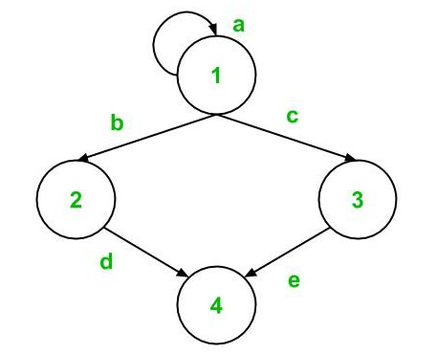

A **Graph Matrix** is used to represent the control flow graph of a program. It's a square matrix where each row and column corresponds to nodes in the control flow graph, and the matrix entries represent edges between these nodes.

**Control Flow Graph**

The control flow graph represents the logical flow of a program by showing nodes (statements or conditions) and edges (flow between nodes). Each node denotes a step in the program, while an edge represents the transition or path between nodes.

**Creating a Graph Matrix**

Given a control flow graph, a graph matrix is built based on the following rules:

* Each row and column in the matrix corresponds to a node in the control flow graph.
* The matrix entries represent the presence of an edge between two nodes.

Example:

|  | **1** | **2** | **3** | **4** |
| --- | --- | --- | --- | --- |
| **1** | a | b | c |  |
| **2** |  |  |  | d |
| **3** |  |  |  | e |
| **4** |  |  |  |  |

Where "a," "b," etc., represent the edges between the respective nodes.

**Connection Matrix**

A **Connection Matrix** simplifies the graph matrix by replacing edge names with weights. If an edge exists between two nodes, the weight is represented by 1; otherwise, the entry is left blank (or implicitly 0).

For the same graph:

|  | **1** | **2** | **3** | **4** |
| --- | --- | --- | --- | --- |
| **1** | 1 | 1 | 1 |  |
| **2** |  |  |  | 1 |
| **3** |  |  |  | 1 |
| **4** |  |  |  |  |

**Cyclomatic Complexity Using Graph Matrices**

Cyclomatic complexity measures the number of linearly independent paths through a program’s source code. It can be computed using the following steps:

1. Count the number of 1’s in each row of the connection matrix.
2. Subtract 1 from the count for each row (ignoring rows with a count of 0).
3. Add the result for each row.
4. Add 1 to the sum from step 3 to obtain the cyclomatic complexity.

This method provides an alternative way to calculate cyclomatic complexity, ensuring comprehensive testing by identifying independent paths that should be covered in test cases.

**Advantages**

* **Visualization**: The graph matrix offers a clear representation of the control flow.
* **Efficient Cyclomatic Complexity Calculation**: It simplifies the process of identifying the complexity of the code.

Q7::::::::::::::::::::::::::::::;;;;

**Data Flow Testing** is a white-box testing technique used to track and ensure the correct flow of data within a program. It focuses on how variables are defined, used, and killed (destroyed) during execution.

**Key Concepts:**

* **Definitions (Def)**: Where a variable is assigned a value.
* **Usage (Use)**: Where a variable is utilized, either computationally or for control.
* **Kill**: The point where a variable’s value is no longer accessible.

**Types of Data Flow Testing:**

* **Def-Use Chains (DU Chains)**: Tracks the sequence between a variable’s definition and its use.
* **Anomalies**: Identifies issues like variables being used without initialization, or variables being defined but never used.

**Goals:**

The primary goal of data flow testing is to ensure that:

* Every definition of a variable is properly used.
* Variables are initialized before use.
* Unnecessary or redundant definitions of variables are eliminated.

**Steps:**

1. Identify all definitions and uses of variables in the code.
2. Track paths between definitions and uses using DU Chains.
3. Create test cases that cover all def-use paths.

**Advantages:**

* Helps in detecting initialization issues.
* Identifies dead code and unnecessary variables.
* Focuses on variables that may cause logical errors.

**Disadvantages:**

* Can be complex for large programs.
* Requires detailed knowledge of variable flows.

**2) Mutation Testing**

**Mutation Testing** is a fault-based testing technique that evaluates the quality of test cases by deliberately introducing small changes (mutations) into a program and observing if the test cases can detect these mutations.

**Key Concepts:**

* **Mutants**: Slightly altered versions of the original program, with one small change (mutation) in the code.
* **Mutation Operators**: Rules that define how mutations are introduced (e.g., replacing an operator + with -).
* **Kill a Mutant**: If a test case detects the introduced fault, it "kills" the mutant.

**Types of Mutation Testing:**

* **Statement Mutations**: Changing or removing statements.
* **Operator Mutations**: Changing operators (arithmetic, relational, etc.).
* **Variable Mutations**: Altering variables or constants.

**Steps:**

1. Introduce a mutation using a mutation operator.
2. Execute the test cases on the mutated code.
3. If a test fails, the mutant is killed. If not, the mutant survives.
4. Refine test cases to kill surviving mutants.

**Advantages:**

* Evaluates the robustness of test cases.
* Forces testers to create comprehensive and efficient tests.

**Disadvantages:**

* Time-consuming as many mutants can be created.
* Requires extensive computation and analysis.

**3) Loop Testing**

**Loop Testing** is a white-box testing technique specifically focused on validating the functionality and performance of loops within a program. Loops are an integral part of control structures and can lead to errors if not properly tested.

**Types of Loops:**

* **Simple Loops**: A loop with a single entry and exit point.
* **Nested Loops**: Loops within other loops.
* **Concatenated Loops**: Multiple loops that are sequentially connected.
* **Unstructured Loops**: Loops with irregular control flow.

**Testing Strategies:**

1. **Zero Iterations**: Test if the loop can handle zero iterations correctly (when loop is not executed).
2. **One Iteration**: Check the loop’s behavior with exactly one iteration.
3. **Multiple Iterations**: Test the loop with a few typical iterations.
4. **Boundary Testing**: Evaluate the loop’s behavior at its boundary values (e.g., maximum iterations).

**Steps:**

1. Identify loops in the control flow.
2. Design test cases for zero, one, and multiple iterations.
3. Test loops for boundary conditions and extreme values.
4. For nested loops, handle inner loops before outer loops.

**Advantages:**

* Detects loop-related errors, such as infinite loops and incorrect loop termination.
* Ensures proper loop performance under different conditions.

**Disadvantages:**

* Can be complex for nested and unstructured loops.
* May miss certain cases if loops depend on complex logic

Q8:::::::::::::::::::::::::::::::::::  
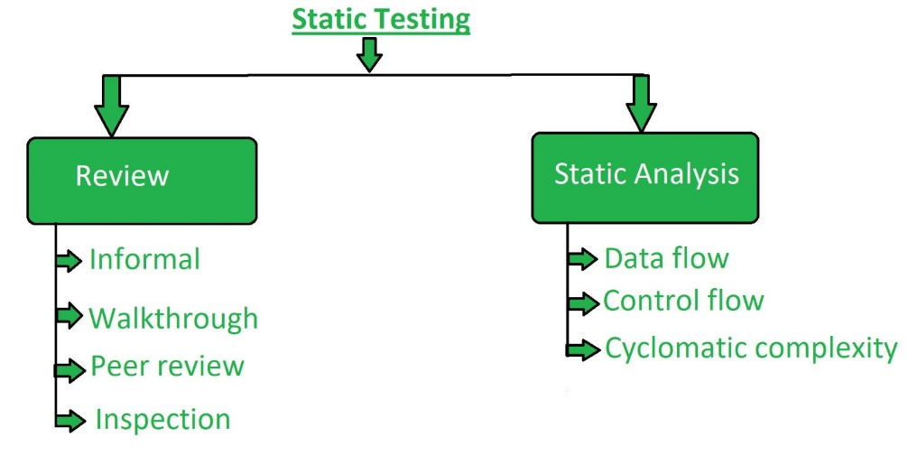

**Static Testing** is a verification technique aimed at detecting defects in software without executing the code. It focuses on reviewing documents, code, and other artifacts in the early stages of development to find and fix bugs before they become costly.

**Key Aspects:**

1. **Verification, not execution**: Involves checking code, design documents, and requirements without running the program.
2. **Manual & automated methods**: Can be done manually (e.g., code reviews) or with automated tools (e.g., linting tools).
3. **Types of Static Testing**:
   * **Review**: Includes formal and informal reviews, walkthroughs, and inspections to detect errors in code, design, and documents.
   * **Static Analysis**: Analyzes code for issues like dead code, unused variables, and adherence to coding standards.

**Need for Static Testing:**

1. **Early bug detection**: Identifies defects in the early stages, reducing cost and effort.
2. **Increased code quality**: Improves software maintainability by ensuring adherence to coding standards.
3. **Complement to dynamic testing**: Detects issues not easily caught through dynamic testing, such as coding anomalies and potential logic errors.

**Techniques:**

1. **Review Techniques**:
   * **Informal Review**: Casual examination to gather opinions.
   * **Walkthrough**: Led by the author, used to explain code and solicit feedback.
   * **Inspection**: A formal, detailed process where peers or experts examine documents for defects.
2. **Static Analysis**:
   * Detects coding errors such as undefined variables, dead code, and infinite loops.
   * Tools like Checkstyle, SonarQube, and Lint are commonly used for code inspection.

**Advantages:**

* **Cost-efficient**: Detects issues early, saving time and resources in later stages.
* **Improves documentation**: Ensures clarity and accuracy in software requirements and design documents.
* **Enhances development productivity**: Reduces defects during production.

**Limitations:**

* **Limited scope**: Cannot detect runtime errors (e.g., memory leaks, performance bottlenecks).
* **Requires skilled reviewers**: Effectiveness depends on the expertise of the team.

Q9::::::::::::::::::::::;;

**Validation Activities in Testing Techniques**

1. **Unit Validation**: This involves testing individual units or components of the software to ensure that each one functions correctly in isolation. It focuses on validating the smallest testable parts of the system, such as methods or functions, typically using white-box testing techniques.
2. **Integration Testing**: After unit validation, integration testing is conducted to test the interaction between different units or components. It validates how components work together and identifies interface issues between modules. This is often done incrementally or through big-bang integration.
3. **Functional Testing**: This black-box testing method ensures that the software functions according to the requirements. It validates that all specified functionalities, such as inputs, outputs, and behaviors, work as expected without considering the internal code structure.
4. **System Testing**: This is a comprehensive validation of the entire integrated system. It includes testing the complete system in a controlled environment to ensure the software meets both functional and non-functional requirements (e.g., performance, security).
5. **Acceptance Testing**: The final phase of validation, acceptance testing, is conducted to determine whether the software is ready for deployment. It checks if the software meets the user's needs and business requirements. This testing is often performed by end-users or clients.

| **Q10:::::**  **Aspect** | **Incremental (Progressive) Testing** | **Regression Testing** |
| --- | --- | --- |
| **Purpose** | Tests new modules progressively as they are integrated into the system. | Ensures that changes or additions to the code do not introduce new bugs. |
| **Focus** | Focuses on integration of new or modified components. | Focuses on verifying that existing functionality remains intact after changes. |
| **Timing** | Conducted after each integration of modules. | Conducted after any code modifications (e.g., bug fixes, feature additions). |
| **Method** | Involves integration of tested units one by one. | Re-runs existing test cases to confirm the software behaves as expected. |
| **Test Strategy** | Bottom-up, top-down, or hybrid integration approaches are used. | Involves re-execution of previously executed test cases or selected test cases. |
|  |  |  |
| **Test Cases** | New test cases are created for each integration step. | Test cases from the existing test suite are reused. |
| **Complexity** | Relatively complex as it requires a step-by-step approach. | Can be automated for efficiency, though manual testing is sometimes necessary. |
| **Scope** | Focuses on the specific module or component being integrated. | Focuses on the entire system to ensure overall integrity. |
| **Tools** | May use general testing tools for integration. | Regression testing is highly automated using tools like Selenium or Ranorex. |
| **Priority** | High for early integration testing, detects issues early. | High during ongoing development to catch issues due to code changes. |

**Definition and Purpose:** **Regression testing** is a critical phase in software development that ensures stability after modifications. It's conducted after code changes (new features, bug fixes, optimizations) to confirm the existing functionalities still work correctly. This preserves the software’s integrity and prevents unintended disruptions.

**When to Perform Regression Testing:**

1. **New functionality addition**: To ensure that new features don’t interfere with the existing code.
2. **Bug fixes**: After defects are fixed to ensure other parts remain unaffected.
3. **Code optimization**: To validate efficiency improvements without introducing errors.

**Process:**

1. **Initial failure**: After the source code is modified, tests often fail due to necessary changes.
2. **Debugging**: Developers debug to identify and resolve bugs.
3. **Test case selection**: Appropriate test cases are selected to validate all impacted areas of the code.
4. **Execution**: Selected test cases are run to verify functionality.
5. **Result**: Ensure changes have not affected other parts of the system.

**Test Case Selection Techniques:**

1. **Select all test cases**: A thorough but inefficient approach.
2. **Random selection**: Only useful when test cases have equal fault detection capabilities.
3. **Modification-based selection**: Choose test cases that cover modified and impacted code.
4. **Priority-based selection**: Assign priority codes to test cases, focusing on the highest priority cases.

**Tools for Regression Testing:**

1. **Selenium**: A popular, open-source tool for web application testing across multiple browsers and platforms. It integrates with CI/CD tools for automated regression testing.
2. **Ranorex Studio**: A comprehensive testing solution offering codeless automation, cross-platform testing, and robust reporting.
3. **testRigor**: Utilizes AI and NLP to automate test creation, allowing for codeless, cross-browser testing.
4. **Sahi Pro**: Provides cross-browser testing with ease of use through scriptless testing and integration with CI tools.
5. **Testlio**: A global testing platform providing on-demand testing with comprehensive reporting for issue prioritization.

**Advantages of Regression Testing:**

1. **Automated testing**: Enhances efficiency and reduces manual efforts.
2. **Comprehensive coverage**: Ensures thorough validation of system functionality.
3. **Parallel testing**: Speeds up execution by running multiple tests concurrently.
4. **Improved product quality**: Reduces bugs and enhances stability.
5. **Cost-effectiveness**: Saves resources in the long run by preventing expensive fixes later in the cycle.

**Disadvantages:**

1. **Time and resource consumption**: Without automation, regression testing can be expensive and time-consuming.
2. **Frequent need**: Even minor changes require re-testing.
3. **False positives/negatives**: Can lead to confusion if test results are not properly interpreted.